Type-C Gigabit To Ethernet Adapter
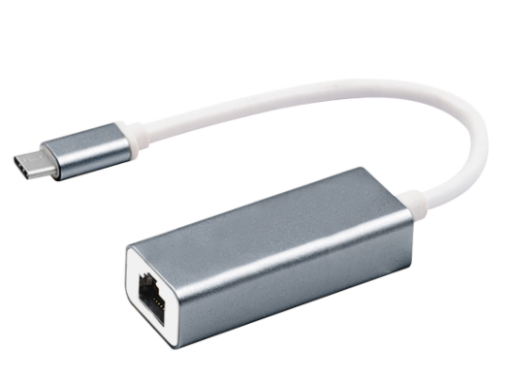

C-TC-LAN1000M

Descrption:
10/100/1000Mbps Instant LAN Connectivity
for your MacTM or WindowsTM
Enabled Type-C Notebook or other Computing Device
Enable instant, wired LAN connectivity at your home or office with the stylish C-TC-LAN1000M which enables up to 1000Mbps (Gigabit) Ethernet connectivity.
Using the high-performance Type-C interface, simply plug into a compatible Type-C port on your MacBookTM, Windows or other notebook or computer which features the next-generation Type-C port, found on many of the latest model of devices. Plug n' Play with no drivers needed, the adapter makes an ideal, faster and more secure connection than slower wireless connectivity

Features:
- Plug and play, no drive
- Support windows /VISTA/WIN7/win8/win8.1/Mac /IOS/ANDROID
- Compatible With: laptop / tablet with USB Type-c interface
- Supports automatic adjustment between 10/100 /1000MBPS
- Supports automatic MDIX (direct and cross-network cable auto-sensing)
- USB interface compatible with 1.0, 1.1 and 2.0 specifications
- Supports full-speed mode Bus-powered capability
- Compatible with IEEE802.3 802.3u. 802.3ab, 10Base-TX100Base-TX, 1000BASE protocol
- Supports duplex, half-work and half-duplex operation in fast Ethernet modules Supports up to 9KB of giant package
- Supports suspend and remote wake-up via interface and Magic package Insert device installation

SPECIFICATIONS
- Chip: RTL8152B
- Interface type: Type-c
- Line length: 17.6cm (±0.2)
- Interface: RJ45*1
- Certification: CE.ROHS,FCC
- Function: Data Transfer
- Package Type: Box

Product Code:
- Product net weight: 26.6g
- Product size: 58.6*23.4*16.4mm
- Barcode: 8400800036612

